Example of how to enter a cash receipt from a customer
- Click on the application “Post Cash Journal Entries” to launch it
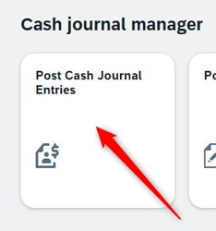
- Make sure you are using the right cash journal. If you wish to change it, click on the button “Change cash journal”
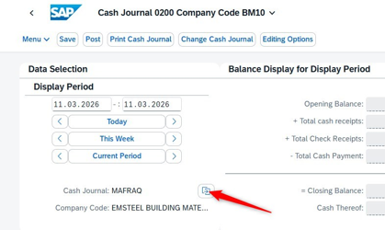
- Choose the period you work with. For example, click on “Today” to see only cash transactions of today
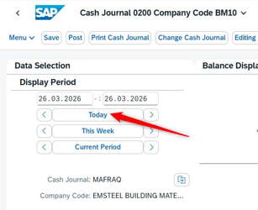
- Click on the tab “Cash Receipts” to enter or display an income of cash
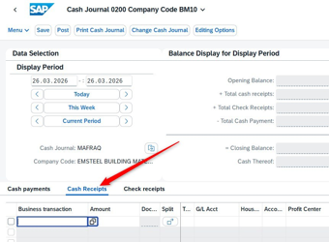
- Click on the search button of the field “Business transaction” to choose a transaction
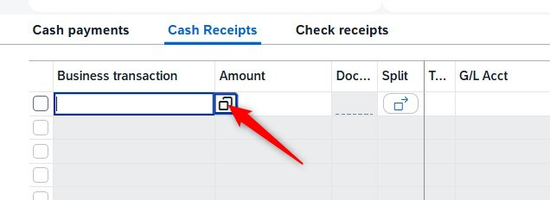
- A pop-up window opens. Click on the button “GO” to launch the searh of business transactions
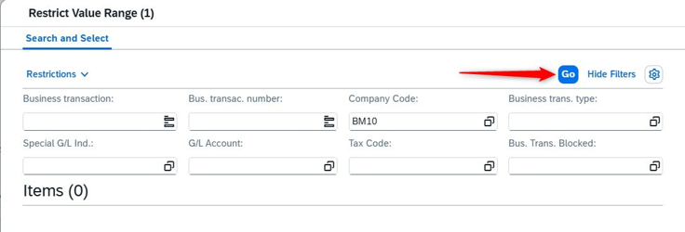
- Select the line with a business transaction you wish to use
For example, “CUSTOMER PAYMENT”.
And click on the button “OK”. The pop-up window closes after that.
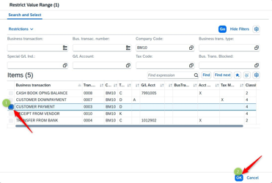
Result: The pop-up window closes, the business transaction name populates the field:
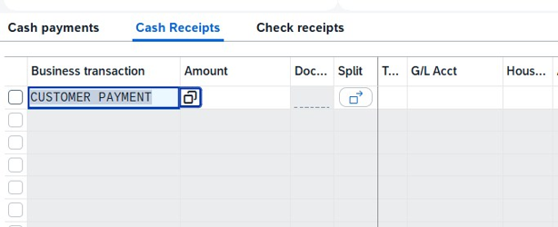
- Enter the required information
The amount in AED:
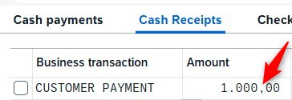
The customer number:
Use the “Search” button to find a customer by its name or other searching filters
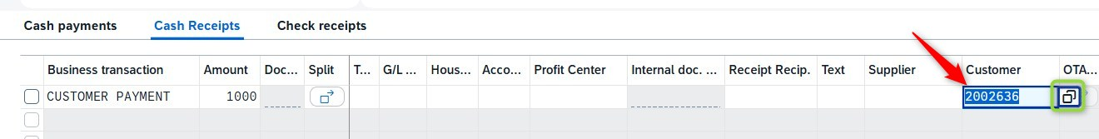
- Press “Enter” on the keyboard
Some fields are populated automatically (dates, profit center etc).
The light status is set to RED or YELLOW: it means that the line is not yet posted.
If the system needs you to fill other required fields, it will underscore them in red.
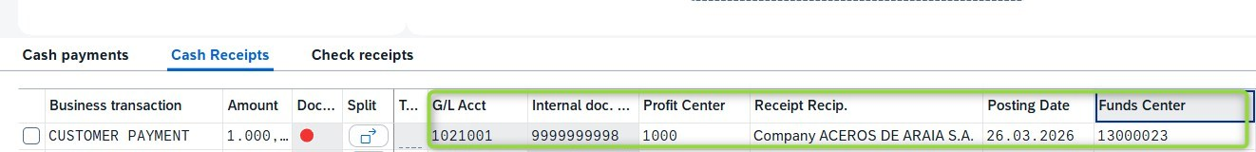
- Fill optional fields with data you wish to save
The Reference, Assignment, Text fields are manually populated.
If the customer provides a sales order number and its item, enter (or search) it in the corresponding field.
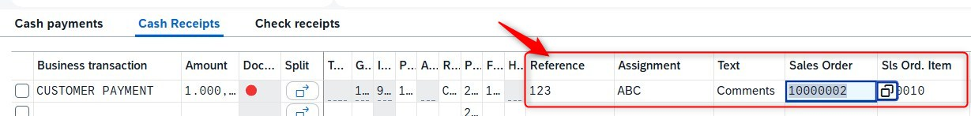
- Select the line and click on the button “Post” to create a cash operation and an accounting document.
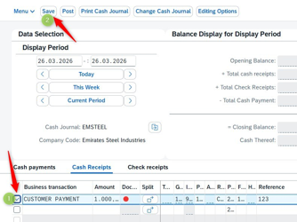
Result: the line gets a light status GREEN
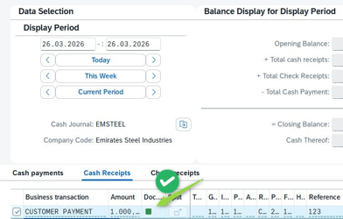
- Make sure the line is selected and click the button “Receipt” to print a paper-result on a local printer
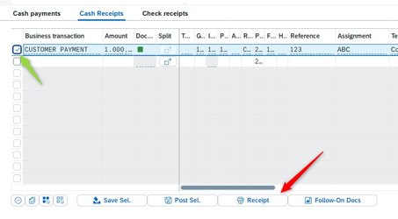
- Select a printer name in a pop-up window and click on “Continue”
For the instruction purposes we indicated a “local virtual” printer that does not physically print paper.
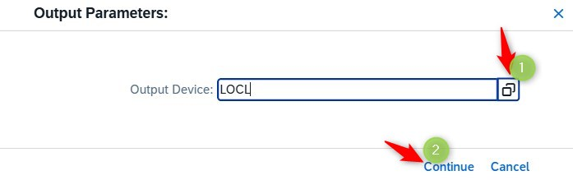
- Click on following buttons to get results:
(1) Print preview on the computer
(2) Save on the computer
(3) Send to print on the chosen previously computer
(4) Exit the current window and return to the cash journal application screen
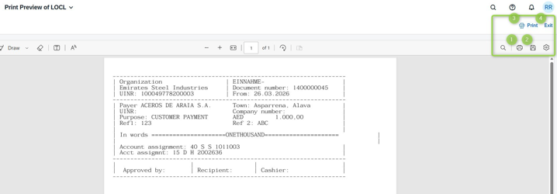
Result: if you click on the exit button, you return to the cash journal application screen.
